Thirteenth Sunday after Pentecost
August 23, 2026
8:30am Worship

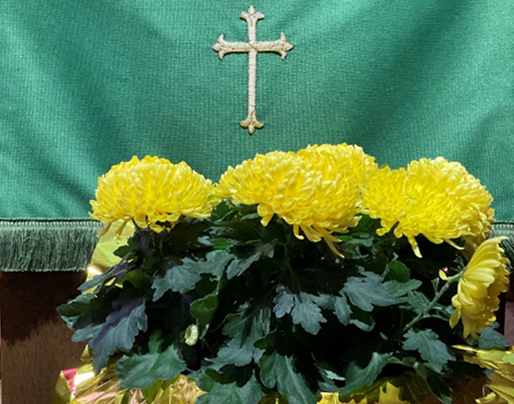

Central Lutheran Church
1857 Potter Street
Eugene, OR 97403
www.welcometocentral.org
Central Lutheran Mission

Our mission is to be the hands and feet of Jesus by loving God and one another, nurturing faithful living, serving those in need, and sharing the Gospel.

Central Lutheran Church, a congregation of the Evangelical Lutheran Church in America and the Oregon Synod, is a Reconciling in Christ community: We affirm that Christ has made us one body with many members, all sharing in God’s wondrous grace and unconditional love.

We celebrate both the human variation and inclusive unity of God's family. Following Jesus' example, we embrace all of God's people, regardless of ethnicity, physical and mental abilities, marital status, sexual orientation, gender identity, gender expression, economic circumstance, and we firmly commit to racial equity. With welcoming hearts, we invite you to join us in worship, education, fellowship, and service.

Central Lutheran Staff

Pastor Laurie A Jones
pastorlaurie@welcometocentral.org
mobile: 206-354-6756

Crystal Miller, Children/Youth Minister for Central/United/Emmaus crystal@unitedlutheran.org

Kelly Colvin-Smith
Parish Administrator
churchoffice@welcometocentral.org
Dr. A. ElRay Stewart-Cook
Organist/Choirmaster
aesc@welcometocentral.org

Dr. Lindsey Henriksen Rodgers
Assoc. Organist/Children’s Music
lindsey.henriksen@gmail.com

Cindy Culpepper
Financial Manager
cindy@welcometocentral.org


Prayers requests may be submitted to: prayers@welcometocentral.org

CALL TO WORSHIP The Carillon

PRELUDE Toccata Quinta (sopra pedali per l’organo, e senza)
Girolamo Frescobaldi

WELCOME

CONFESSION AND FORGIVENESS
Blessed be the holy Trinity, ☩ one God, whose compassion endures forever.
Amen.

Let us confess our sin in presence of God and of one another.

Silence is kept for reflection.

Compassionate God,
We confess to you all our sins. Our burden is heavy, and we cannot free ourselves. In your mercy, call us back to you. Your yoke is easy and your burden is light. Restore us to dwell in your peace. In Christ’s name we pray. Amen.

Jesus says, “Come to me, all you who are weary and are carrying heavy burdens, and I will give you rest.” In the name of God, Father, ☩ Son, and Holy Spirit, your sins are forgiven. Rest in God’s love. Amen.

ENTRANCE HYMN #652 Built on a Rock
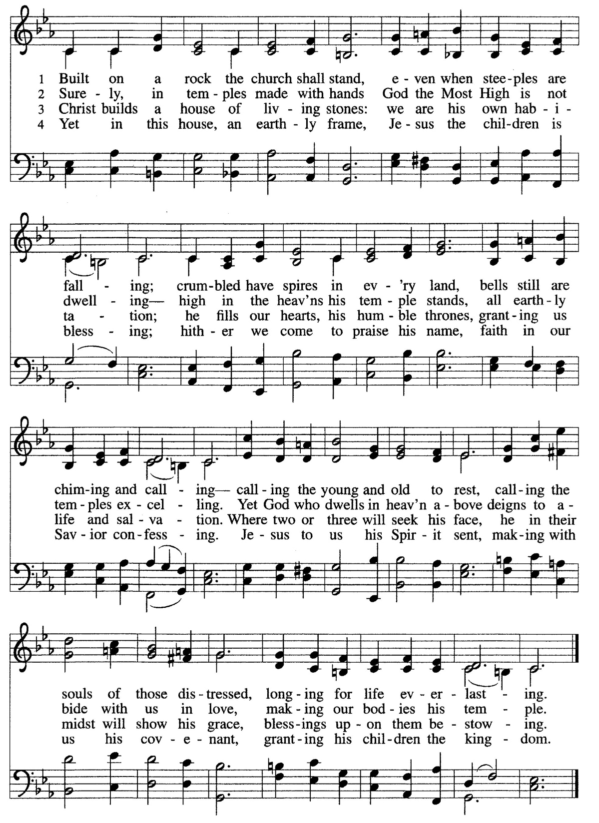

GREETING
The grace of our Lord Jesus Christ, the love of God, and the communion of the Holy Spirit be with you all. And also with you.

KYRIE

GLORIA

PRAYER OF THE DAY
Let us pray. O God, with all your faithful followers of every age, we praise you, the rock of our life. Be our strong foundation and form us into the body of your Son, that we may gladly minister to all the world, through Jesus Christ, our Savior and Lord. Amen. (you may be seated)

FIRST LESSON Isaiah 28:14-22
Therefore hear the word of the Lord, you scoffers who rule this people in Jerusalem. Because you have said, “We have made a covenant with death, and with Sheol we have an agreement; when the overwhelming scourge passes through it will not come to us, for we have made lies our refuge, and in falsehood we have taken shelter”; therefore thus says the Lord God,
“See, I am laying in Zion a foundation stone, a tested stone, a precious cornerstone, a sure foundation: ‘One who trusts will not panic.’ And I will make justice the line and righteousness the plummet; hail will sweep away the refuge of lies, and waters will overwhelm the shelter. Then your covenant with death will be annulled, and your agreement with Sheol will not stand; when the overwhelming scourge passes through, you will be beaten down by it. As often as it passes through, it will take you, for morning by morning it will pass through, by day and by night, and it will be sheer terror to understand the message.” For the bed is too short to stretch oneself on it, and the covering is too narrow to wrap oneself in it. For the Lord will rise up as on Mount Perazim; he will rage as in the valley of Gibeon to do his deed—strange is his deed!—and to work his work—alien is his work! Now therefore do not scoff, or your bonds will be made stronger,
for I have heard a decree of destruction from the Lord God of hosts upon the whole land. The word of the Lord. Thanks be to God.

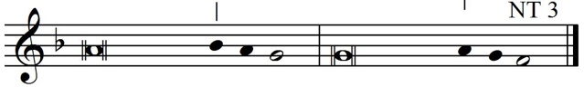
PSALM 138

I will give thanks to you, O Lord, with | my whole heart;
before the gods I will | sing your praise.
I will bow down toward your holy temple and praise your name,
because of your steadfast | love and faithfulness;
for you have glorified your name and your word a- | bove all things.
When I called, you | answered me;
you increased my | strength within me.
All the rulers of the earth will praise | you, O Lord,
when they have heard the words | of your mouth.
They will sing of the ways | of the Lord,
that great is the glory | of the Lord.
The Lord is high, yet cares | for the lowly,
perceiving the haughty | from afar.
Though I walk in the midst of trouble, you | keep me safe;
you stretch forth your hand against the fury of my enemies; your
right | hand shall save me.
You will make good your pur- | pose for me;
O Lord, your steadfast love endures forever; do not abandon
the works | of your hands.
Glory be to the Father, and to the | Son, and to the | Holy Spirit.
As it was in the beginning, is | now, and will be fore- | ver. Amen.

ANTHEM Ancient of Days – William Allen Pasch Cantors

SECOND LESSON Romans 12:1-8
I appeal to you therefore, brothers and sisters, on the basis of God’s mercy, to present your bodies as a living sacrifice, holy and acceptable to God, which is your reasonable act of worship. Do not be conformed to this age, but be transformed by the renewing of the mind, so that you may discern what is the will of God—what is good and acceptable and perfect. For by the grace given to me I say to everyone among you not to think of yourself more highly than you ought to think but to think with sober judgment, each according to the measure of faith that God has assigned. For as in one body we have many members and not all the members have the same function, so we, who are many, are one body in Christ, and individually we are members one of another. We have gifts that differ according to the grace given to us: prophecy, in proportion to faith; ministry, in ministering; the teacher, in teaching; the encourager, in encouragement; the giver, in sincerity; the leader, in diligence; the compassionate, in cheerfulness.
The word of the Lord. Thanks be to God.

GOSPEL ACCLAMATION (please stand as you are able)
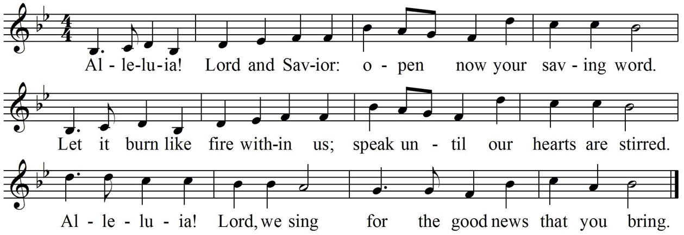

GOSPEL Matthew 16:13-20
The gospel according to Matthew, the 16th chapter. Glory to you, O Lord.
Now when Jesus came into the district of Caesarea Philippi, he asked his disciples, “Who do people say that the Son of Man is?” And they said, “Some say John the Baptist but others Elijah and still others Jeremiah or one of the prophets.” He said to them, “But who do you say that I am?” Simon Peter answered, “You are the Messiah, the Son of the living God.” And Jesus answered him, “Blessed are you, Simon son of Jonah! For flesh and blood has not revealed this to you but my Father in heaven. And I tell you, you are Peter, and on this rock I will build my church, and the gates of Hades will not prevail against it. I will give you the keys of the kingdom of heaven, and whatever you bind on earth will be bound in heaven, and whatever you loose on earth will be loosed in heaven.” Then he sternly ordered the disciples not to tell anyone that he was the Messiah.
The Gospel of the Lord. Praise to you, O Christ.

SERMON Dr. Dennis Lindsay

HYMN #623 Rock of Ages (please stand)
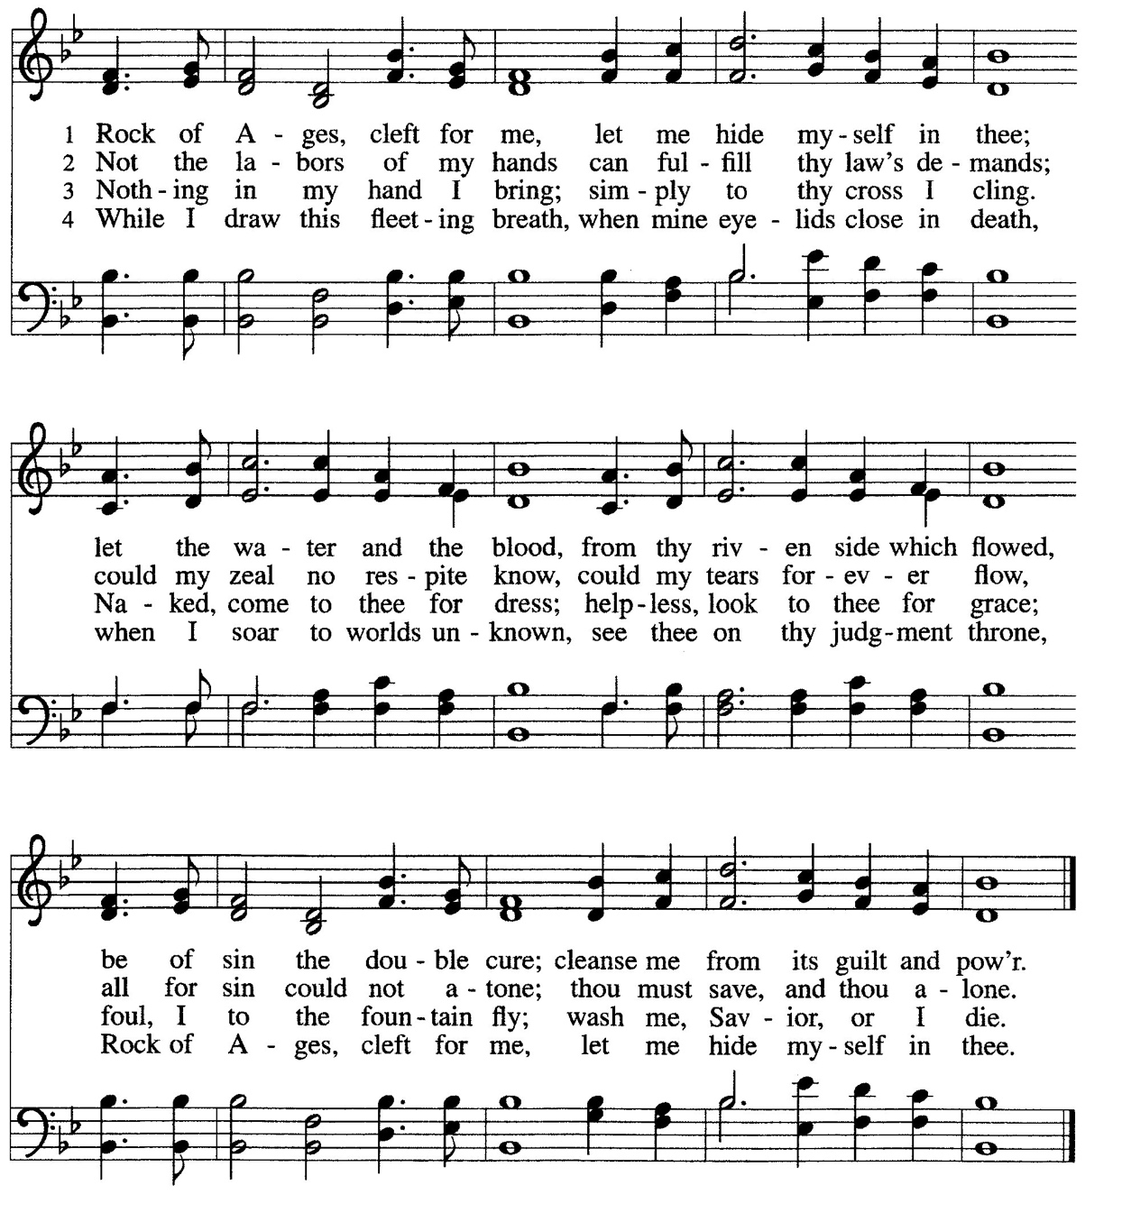

Apostles’ Creed
With the whole church throughout the ages, let us profess our Christian faith using the words of the Apostles’ Creed:
I believe in God, the Father almighty, creator of heaven and earth.

I believe in Jesus Christ, God's only Son, our Lord, who was conceived by the Holy Spirit, born of the virgin Mary, suffered under Pontius Pilate, was crucified, died, and was buried; he descended to the dead. On the third day he rose again; he ascended into heaven, he is seated at the right hand of the Father, and he will come to judge the living and the dead.

I believe in the Holy Spirit, the holy catholic Church, the communion of saints, the forgiveness of sins, the resurrection of the body, and the life everlasting. Amen. (please be seated)

PRAYERS OF INTERCESSION

When the leader says, “God of grace,”
you are invited to respond, “Hear our prayer.”

PEACE
The peace of Christ be with you always. And also with you.

OUR LIFE TOGETHER

ANTHEM O Taste and See – Heinrich Isaac Cantors

OFFERING
You are invited to place your offering
in the plate as you come forward for communion.

OFFERTORY PRAYER
Let us pray. Loving God, we offer at your table the gifts of our hearts.
Help us take heart in you and share freely of your love, so that all creation can taste your abundance. We ask this in the name of Jesus, through the Spirit abiding with us now and forever. In the name of Jesus, Amen.

GREAT THANKSGIVING (please stand as you’re able)

PROPER PREFACE
It is indeed right, our duty and our joy, that we should at all times and in all places give thanks and praise to you, almighty and merciful God; through Christ our Lord; who rose beyond the bounds of death, and on this day as he had promised, poured out your Spirit of life and power upon the chosen disciples. At this the whole earth exalts in boundless joy. And so, with the Church on earth and the hosts of heaven, we praise your name and join their unending hymn:

SANCTUS

WORDS OF INSTITUTION
In the night in which he was betrayed, our Lord Jesus took bread and gave thanks; broke it, and gave it to his disciples, saying: Take and eat; this is my body, given for you. Do this for the remembrance of me.

Again after supper, he took the cup, gave thanks, and gave it for all to drink, saying: This cup is the new covenant in my blood, shed for you and for all people for the forgiveness of sin. Do this for the remembrance of me

LORD’S PRAYER
Gathered into one by the Holy Spirit let us pray as Jesus taught us:
Our Father, who art in heaven, hallowed be thy name, thy kingdom come, thy will be done, on earth as it is in heaven. Give us this day our daily bread; and forgive us our trespasses, as we forgive those who trespass against us; and lead us not into temptation but deliver us from evil. For thine is the kingdom, and the power, and the glory, forever, and ever. Amen. (please be seated)

COMMUNION INSTRUCTIONS

LAMB OF GOD
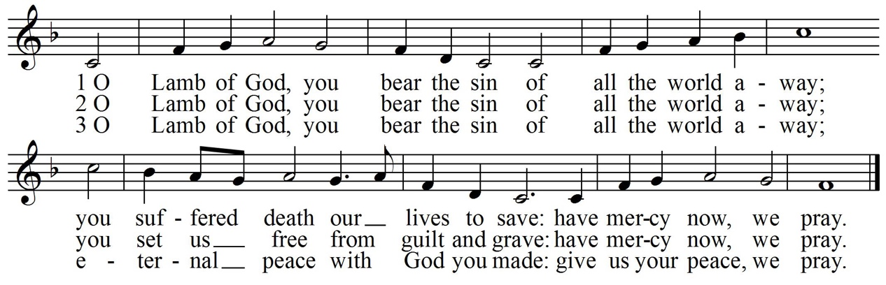

COMMUNION DISTRBUTION

BLESSING AFTER COMMUNION
The body and blood of our Lord Jesus Christ strengthen you and keep you
in his grace. Amen.

PRAYER AFTER COMMUNION
Let us pray. Compassionate God, through the gifts of bread and wine
our hearts are filled with the abundance of your love. Strengthen us that we, through this holy meal, may share your love freely, as you have shared with us. We ask this in the name of Jesus, through the Spirit nourishing us now and forever. Amen.

BENEDICTION (please stand)
Creator, Redeemer, Sustainer, ☩ one God, bless, heal, and hold you
today and always. Amen.

HYMN #814 Faith of Our Fathers

DISMISSAL
Go in peace to share the good news! Thanks be to God.

We invite you to remain seated through the voluntary; however, if you choose to depart, we kindly ask you to do so in silence.

ORGAN VOLUNTARY Piece d’Orgue (BWV 572) - Johann Sebastian Bach

The liturgy is adapted from the Evangelical Lutheran Worship, © 2006, Augsburg Fortress, with permission to reproduce and podcast/stream the music in this service obtained from ONE LICENSE with license A-706755. All rights reserved.

Today’s Cantors: Taylor Huett, Naomi Castro, Steve Rodgers, Dylan Bunten

For additional information on weekly and upcoming events visit our website welcometocentral.org.

Interested in membership at Central? We invite you to fill out a pew
card and place it in the offering plate so we can contact you with more information.

The Church Council is calling a special meeting of the congregation following worship on Sunday, August 30th to vote on a revision to the 2026 Budget approved at the semi-annual meeting in January 2026, in order to add a Compensation & Benefits package in anticipation of calling an Associate Pastor.

